Marlena Schuster
Lesson Plan: 6th Grade Band, MS 54
Date: 3 February, 2020

Overview: Students will participate in the “Do Now,” where a student will share a song of their choosing and students will respond and react. Students will warm up independently with long-tones. Students will identify and be able to recreate pitches C, D, E, F, and G (in the treble clef) on their clarinets and trumpets. Students will be able to recognize and recreate a simple and familiar melody on their instruments through aural skills. Students will show musical literacy through transcription.

- Students will listen and write down what they hear and their thoughts regarding the Do Now and the one sharing will call on students. Teacher will lead the discussion and ask questions that require deeper synthesis and thought.
- Students will get their instruments and warm up independently with long-tones, between C and G in the treble clef.
- “Now that we’re warmed up, everyone, let’s play from C to G and back down.” (students will play as teacher walks around, making note of issues to address.) “Now, let’s go from G to C and back up!” (continues walking around, fixing any remaining issues or getting neighbors to help clarify fingerings or valve positions, etc.)
- “Now, I’m going to play a chunk of the melody we’ve been working on. Finger and press valves along with me, don’t make any noise, just finger along, and then I’d like to see if any volunteers can play that chunk back for me.” (Play the first half of Mary had a Little Lamb, then call on 3-4 volunteers to play it back.)
- “Great! Now, raise your hand if you can play that much of the piece. Great! I’m proud of you all. Now I’d like to see if we can all play the whole thing together by memory. Let’s go!” Play the whole thing by memory with them.
- “Now everybody please take out a piece of staff paper. We’re going to do a transcription in 2 parts. Since we know the note names, let’s first write out the letters. Write these above the staff, so starting with writing the letter E. You have 3 minutes, go! And remember, this will be collected. Not for a grade, but just to make sure everyone is on track.” (Give students about 3 minutes to do this, walking around and making sure students are on track.)
- Great! Now, I know we briefly talked about the rhythm and note values, but for now, let’s just write the notes out on the staff with circles. I’ll give you the first one, then you finish it!” (Write an E circle on the staff on the board.) “You have 3 minutes, go!”
- “Great job, everyone! Now as a final point, why do we think that transcriptions are important?” (Help students realize that musical literacy is a very important part of being in an ensemble and also practicing music on your own). “Please write your name on your papers and hand leave them on the music stand on your way out. You can put your instruments away! Great job everyone!”

Key points:
- Literacy
- Aural skills
- Dictation
- Recall
- Music appreciation
- Analyzation
- Critical thinking

Assessment:
Assessment for understanding and comprehension of the task will be done both formally and informally. Informal assessment will be done by walking throughout the students as they complete the assigned tasks and fixing issues as I see fit. Formal assessment will take place upon evaluation of their turned in assignments to see if they were able to complete the task of writing out the notes both in letters and on the staff.

Modifications:
There are a few students in this class with IEPs. The students in this particular class are capable of completing the assignments as written; however as a possible modification, students who are unable to play the entire piece on their instrument could play what they can based on my knowledge of their motor skills, and/or be able to write out an assessment of anything they know about the piece if they are struggling with note recognition rather than do an aural dictation.

NAfME Standards Addressed:

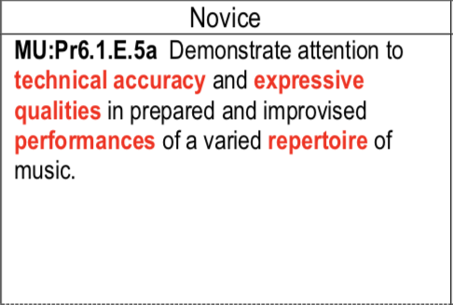 (Present)
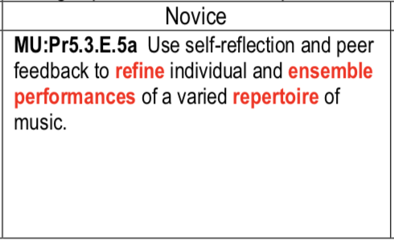 (Rehearse, evaluate, refine
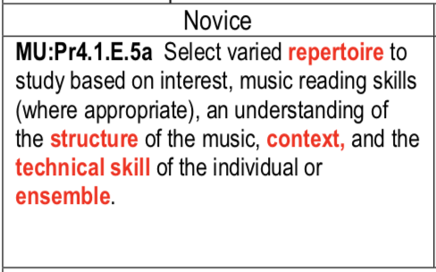(Analyze)

